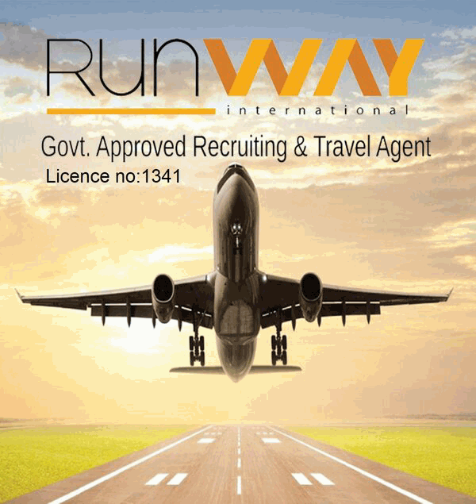
Runway International

photo
RL -1341
Address: Al-Razi Complex , 166/167,
Sayed Nazrul Islam Soroni, Purana Paltan, Dhaka
Email : info.runwayinternational@gmail.com
Employee information form
Employee Name
Passport No.
Applied Position

Age |  |  |  | Date of birth
Nationality | BANGLADESHI |  |  | Religion
Gender |  |  |  | Marital status
Height |  |  |  | Weight
Body Size |  |  |  | Foot Size
Employee’s Contact No |  |  |  | Educational  Qualification
Father’s Name
Mother’s Name
Work Experience
Year/Company Name
Overseas/Local Experience
Language |  | SPEAKING |  | English | SPEAKING
Language |  | WRITTING |  | English | WRITTING
Language |  | READING |  | English | READING
Emergence Contact  Person in Home Country | Name |  |  | Relation of  Employee
Permanent address:
Employee signature:

Date:
REF-
Result:
A
B
C
F

Interviewer signature

